Project Report
- Aim:
The goal of this project is to propose a network architecture for a new Internet startup G4A unit. The network proposed should be able to handle 200 games simultaneously and it should be geographically distributed around 3 regions – Europe, Asia, and North America.
- Specifications:
- Support 200 simultaneous games
- Each player needs around 256Kbps of up/down the speed to the server to have a good gaming experience.
- 1000 players per map
- The Player has to download 100 kbytes of data from the main site on average every 30 min.
- In all regions the load is divided as follows:
- Europe (Paris, Helsinki) (50/50)
- Asia (Beijing, India, South Korea) (33/33/33)
- North America (New York, San Jose) (50/50)

- Capacity calculations:

3.1 Main Site:
- The main site is responsible for coordinating the regional data centers, updating software at regional data centers and player information, etc.
- To provide an uninterrupted gaming experience, let us assume for every city the game should be downloaded to the server within 10seconds.
- The link capacities from the main site to different regional data centers is as follows:
  - The link capacity from the main site to RDC in Europe region = (50 1000 800Kb)/10s = 4 Gbps.
  - The link capacity from the main site to RDC in Asia region = (17 1000 800Kb)/10s = 1.34 Gbps.
  - The link capacity from the main site to RDC in the North America region = (25 1000 800Kb)/10s = 2 Gbps.
- Total link capacity that to handle by the main site = (4*2 + 1.34 *3 + 2* 2) Gbps ≈ 16.02 Gbps.
3.2 Europe region:
- In the European region, only 50% of games are distributed which means only 100 out of 200 games are handled here. This region is divided into 2 cities and the load is distributed equally between them. So, each city will handle 50 games.
- To handle 50 games in each city, the link capacity we need to use is 50*256kbps*1000=12.8Gbps. So, we can buy a 10+2Gbps+800Mbps combination package from ISP to control such traffic.

3.3 Asia region:
- In the Asia region, 25% of games are distributed which means only 50 out of 200 games are handled here. This region is divided into 3 cities and the load is distributed equally between them. So, each city will handle 17 games.
- To handle 17 games in each city, the link capacity we need to use is 17*256kbps*1000=4.3Gbps. So, we can buy a 4Gbps+200+100Mbps combination package from ISP to control such traffic.
3.4 North America:
- In the North American region, 25% of games are distributed which means only 50 out of 200 games are handled here. This region is divided into 2 cities and the load is distributed equally between them. So, each city will handle 25 games.
- To handle 25 games in each city, the link capacity we need to use is 25*256kbps*1000=6.4Gbps.
- So, we can buy a 4+2Gbps+400Mbps combination package from ISP to control such traffic.
- In all regions, the link capacities are full-duplex, so that they can handle uplink and downlink traffic simultaneously.
3.5 Link Capacities for every region for 256Mbps:
EUROPE |  | NORTH AMERICA |  | ASIA
Paris | Helsinki | San Jose | New York | Hyderabad | Beijing | Seoul
50 games | 50 games | 25 games | 25 games | 17 games | 17 games | 17 games
50000 | 50000 | 25000 | 25000 | 17000 | 17000 | 17000
12.8Gbps | 12.8Gbps | 6.4Gbps | 6.4Gbps | 4.3Gbps | 4.3Gbps | 4.3Gbps

- Overview of Network Architecture:
- The topology used in this report is central. All the regions are connected to the main site through the internet to coordinate software updates, introducing new games, player information, etc.
- There are 3 regions in this proposed architecture. Each region is divided into cities and the load is equally distributed between them.
- The 3 regions are Europe, Asia, North America. The European region is divided into 2 cities they are Paris, Helsinki. Asia region is divided into 3 cities they are Hyderabad, Beijing, Seol, and the North America region is divided into 2 cities they are San Jose, New York.
- The total link capacities for the proposed architecture to handle 200 simultaneously games are (12.8*2+4.3*3+6.4*2) Gbps=51.3Gbps
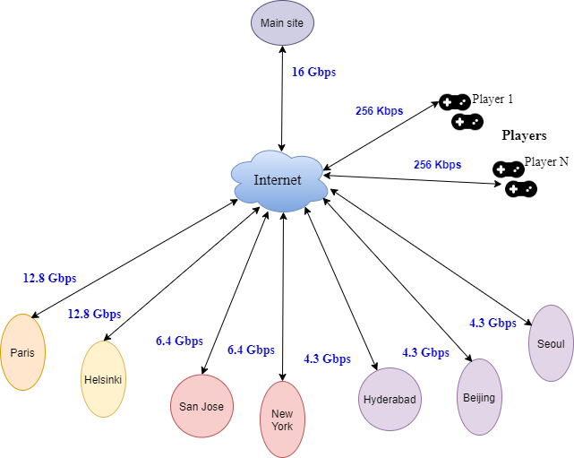

Fig.1 Overview of Network Architecture

- Network Architecture for both city data center and Main site:
- In the below architecture, the city data center is connected to two ISPs to provide redundancy at the demarcation point. The demarcation point is the dividing line where your service provider's equipment connects with your own.
- These routers are connected to the internal network through firewalls to provide security and also acts like a filter for incoming and outgoing traffic.
- The internal routers are connected to the servers via switch. The internal servers are virtualized servers so that they can handle multiple users at the same time.
- The total number of physical/virtual servers to be used in the data center depends on the traffic. The particular site has to handle and also on the capacity of each physical server that is deployed. The larger the capacity of the physical server, the higher will be the cost of the network.
- In the below architecture we have 2 demarcation routers, 2 switches, and 2 internal routers. Only one of the two denomination routers, switches, and internal routers is used but the second one is added as a backup in case of failure.
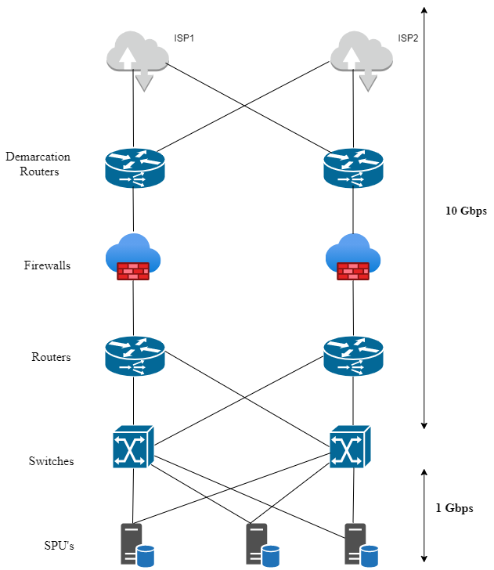
Fig.2 Network Architecture for both city data center and Main site

- Port’s capacity, Link speed, and network devices at network architecture:
The following table describes the uplink and downlink ports of all city datacenter in the proposed architecture. In each city data center, the demarcation router, switches, and router used = 2 (1 to provide redundancy).
® refers to redundant in all the below tables, the total number of ports not include redundant ports.
Table 1: Network Devices and vendors selected

Network Device | Vendor & Model | Number of Ports Supported
Demarcation routers | Cisco ASR 920 Router, ASR-920-24TZ-M | 24 * 1GE + 4 * 10GE
Switches | Cisco SF350-24 24-Port 1/10 Managed Switch | 24 * 1/10G
Routers | Cisco ASR 920 Router, ASR-920-24TZ-M | 24 * 1GE + 4 * 10GE

Table 2: Network Devices and number of Ports (Main Site)

Network Device | Uplink Ports | Down Link Ports | Total Ports
Demarcation routers | 2x10GE+(2x10GE)® | 16x1GE+(16x1GE)® | 18
Switches | 2x10GE+(2x10GE)® | 2x10GE+(2x10GE)® | 4
Routers | 2x10GE+(2x10GE)® | 2x10GE+(2x10GE)® | 4

Table 3: Network Devices and number of Ports (City Datacenter in Europe)

Network Device | Uplink Ports | Down Link Ports | Total Ports
Demarcation routers | 2x10GE+(2x10GE) ® | 13x1GE+(13x1GE) ® | 15
Switches | 2x10GE+(2x10GE)® | 2x10GE+(2x10GE) ® | 4
Routers | 2x10GE+1GE+(2x10GE+1GE) ® | 2x10GE+(2x10GE)® | 6

Table 4: Network Devices and number of Ports (City Datacenter in Asia)

Network Device | Uplink Ports | Down Link Ports | Total Ports
Demarcation routers | 1x10GE+(1x10GE) ® | 5x1GE+(5x1GE) ® | 6
Switches | 1x10GE+(1x10GE)® | 1x10GE+(1x10GE) ® | 2
Routers | 1x10GE+1x1GE+(1x1GE+1x1GE) ® | 1x10GE+(1x10GE)® | 3

Table 5: Network Devices and number of Ports (City Datacenter in NorthAmerica)

Network Device | Uplink Ports | Down Link Ports | Total Ports
Demarcation routers | 1x10GE+(1x10GE) ® | 7x1GE+(7x1GE) ® | 8
Switches | 1x10GE+(1x10GE)® | 1x10GE+(1x10GE) ® | 2
Routers | 1x10GE+1x1GE+(1x10GE+1x1GE) ® | 1x10GE+(1x10GE)® | 3

- Required physical servers to handle 200 games simultaneously:
- A physical server can configure 2-6 virtual machines, if we configure more than 3 virtual machines, we may face problems due to increased traffic. So, a physical server that has 3 virtual machines deformed in it is selected in this case. In our case, virtual servers are used for gaming. Here each server can only one game at a time
- In the European region, each city has 50 games. We need 50 virtual servers for each city. So, 50/3 = 17 physical servers for each city. Therefore, we want 34 physical servers for the entire Europe region.
- In the Asia region, each city has 17 games. We need 17 virtual servers for each city. So, 17/3 = 6 physical servers for each city. Therefore, we want 18 physical servers for the entire Asia region.
- In the North American region, each city has 25 games. We need 25 virtual servers for each city. So, 25/3 = 9 physical servers for each city. Therefore, we want 18 physical servers for the entire North America region.
- So overall required physical servers to handle 200 games simultaneously= 34(Europe) + 18(Asia) + 18(North America) = 70 physical servers.

- Growth:
- Due to growth, Network architecture faces may some problems like requires a huge amount of financial investment, Greater risk of hardware failures causing bigger disruptions, etc. So, in this section, we would like to discuss how the network should be scaled if the number total of games increases from 200 to 300.
- If GA4 wants to increase the growth, then we should increase the number of virtual servers and speed of link capacity from the main site to each region.
- If the total games increase from 200 to 300 then they will be distributed among all the regions as mentioned in the table below.
- From the above calculation part, we known the speed of Europe is 12.8 Gbps for each city (50 games). To handle 75 games in each city of Europe the required speed is 75 * 256 Mbps = 19.2 Gbps (for Paris and Helsinki). Similarly, the above calculations are provided for other regions also.

Table 7: Speed after adding the growth (200 games to 300)
Region | Games for each  city | Speed before  growth | Games for each  city after adding growth | Speed after  adding growth
Europe | 50 | 12.8 Gbps | 75 | 19.2 Gbps
Asia | 17 | 4.3 Gbps | 25 | 6.45 Gbps
North  America | 25 | 6.4 Gbps | 37 | 9.6 Gbps

- As from the above calculation part, we knew that 70 physical servers are required 200 games where each physical server consists of 3 virtual servers which are deformed in it.
- To find the required servers to handle 300 games, consider European region handles 75 games for each city. we need 75 virtual servers for each city. So, 75/3 = 25 physical servers for each city. Therefore, we want 50 physical servers for the entire Europe region.
- Similarly, the above calculations are provided for other regions also.

Table7: Servers after adding the growth (200 games to 300)

Region | Games for each city | Servers before growth | Games for each city after adding  growth | Servers after adding  growth
Europe | 50 | 34 | 75 | 50
Asia | 17 | 18 | 25 | 27
North  America | 25 | 18 | 37 | 24

- Monitoring:
- It is responsible for storage, aggregation, visualization, and initiating automated responses when the values meet specific requirements. The metrics like Bandwidth usage, Latency, Throughput, Availability, Connectivity must be kept on track.
- Bandwidth usage: This indicates that your network is sending as much data as it can within a period of time but isn’t being overloaded.
- Availability: Network availability is also known as uptime. This indicates whether the network is currently operational, or it goes down.
- Latency: This indicates any delay that happens when a device is requesting data.
- Throughput: It measures the percentage of data packets that are successfully being sent. A low throughput means there are a lot of failed or dropped packets that need to be sent again.
- Connectivity: It measures the connection between the nodes of the network and tells whether the network is working properly or not.
- We have various monitoring tools like Nagios, PRTG, Circinus, etc, among them, Nagios is efficient because it is open-source, provides a centralized view of the entire IT infrastructure, and detailed up-to-date status information through Nagios GUI. It has good community support; fast, reliable, and detailed monitoring. In Nagios, any service and host first go into the soft state, and next it goes into the hard state and a notification is sent only in the hard state.
- Nagios monitors the above-mentioned metrics and keeps track of it and alerts the admins about a problem in the system beforehand.

